Final Assessment Test Lab Examination – November 2017

Name:-Saikumar . k

Reg:-13MSE1094 Faculty:- Prof. Ilakiyaselvan N

**QUESTION:-1**

1. With the increase in the number of patients visiting in Polyclinic, it has become difficult to manage the appointment system manually. The purpose of the online system is to solve these complications by creating custom-built software to manage the appointment system. For the receptionist it makes easy to set date and time for the treatment of the patient to the relevant doctor. Doctor enters medical prescription and receptionist takes the print. It also helps to maintain doctor’s consultation fee, Laboratories and Testing charges automatically. It also includes a module for maintaining the employee salary and its expenses.
2. Perform class analysis for the above system.

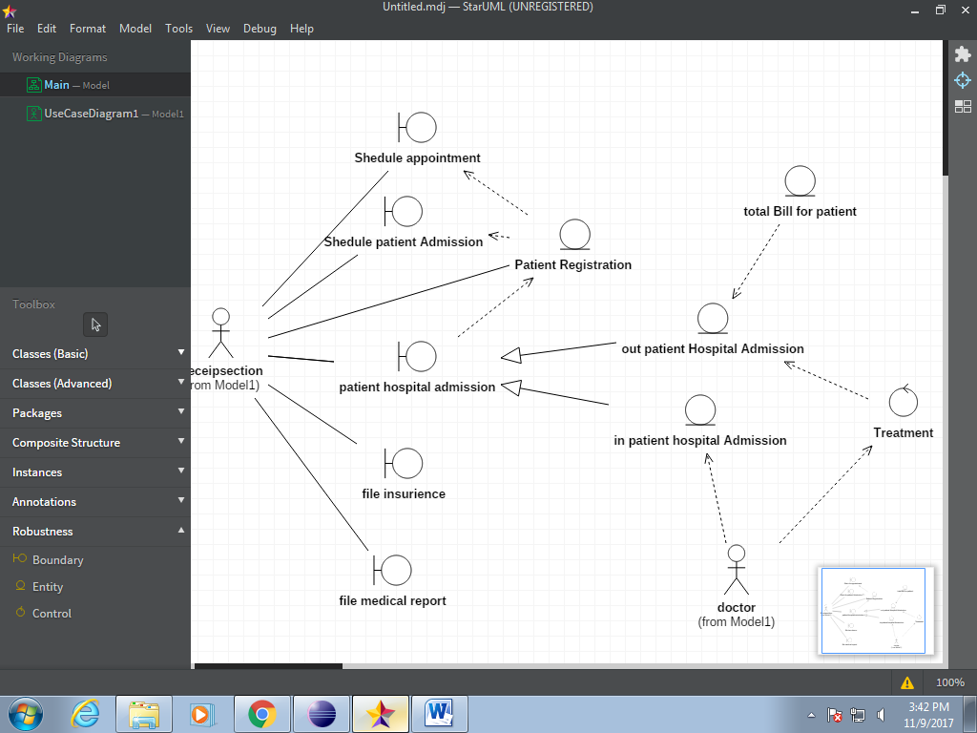

1. Create a login page and registration form for the above system using JForm design.

LOGIN PAGE:-

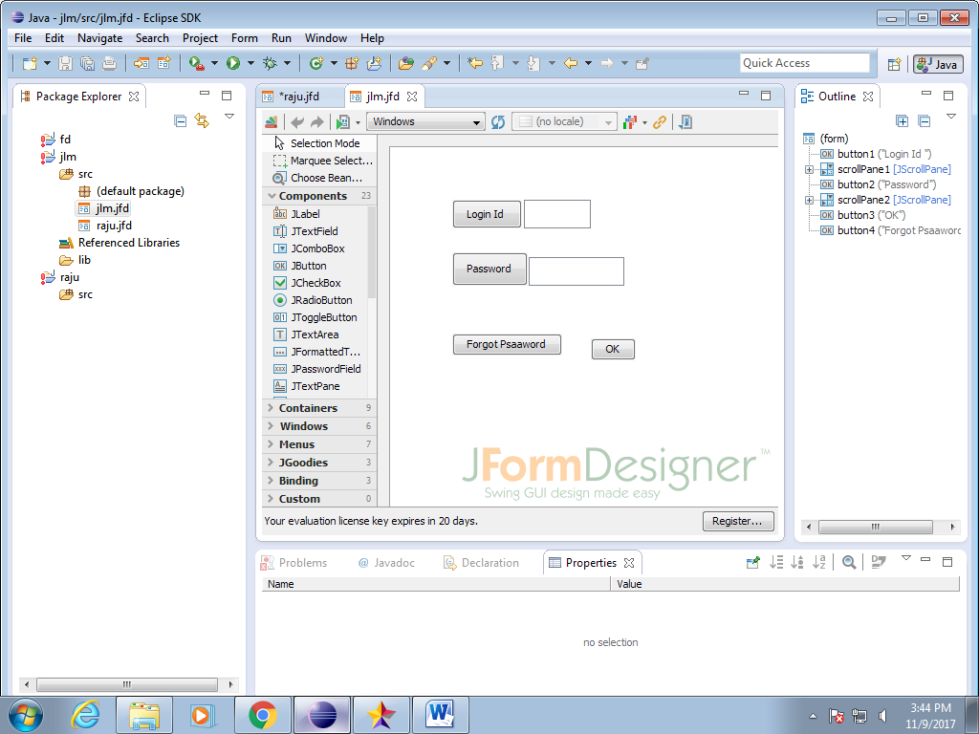

REGISTRATION FORM

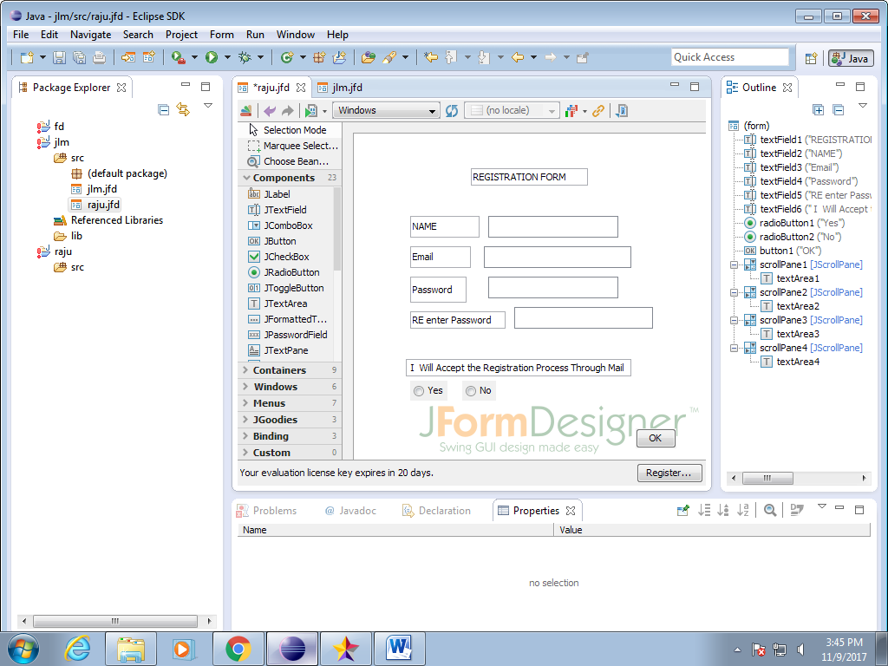

c) Manage the various versions of the above application by using GITHUB.

New Repository Command line :-

echo "# employee-management" >> README.md

git init

git add README.md

git commit -m "first commit"

git remote add origin https://github.com/raju1595/employee-management.git

git push -u origin master

**existing repository from the command line**

git remote add origin https://github.com/raju1595/employee-management.git

git push -u origin master

IMPORT THE code :-

